**A**

**MINOR PROJECT REPORT**

**ON**

Wireless E-Notice Board

Submitted in fulfillment of the requirement for the Award Degree

of

Bachelor of Technology

In

Electronics & Telecommunication Engineering

Of

Government College Of Engineering, Karad

Submitted By

Akash S.Deshmukh

(14153201)

Under Guidance Of

Prof.S.R.Suryawanshi 



**DEPARTMENT OF ELECTRONICS &**

**TELECOMMUNICATION ENGINEERING,**

**GOVERNMENT COLLEGE OF ENGINEERING,**

**KARAD-415124**

**[2018-19]**

GOVERNMENT COLLEGE OF ENGINEERING,

KARAD

Department Of Electronics & Telecommunication

Engineering



CERTIFICATE

*This is to certify that the project entitled* ***“Wireless E- Notice Board”*** *has been carried out under the guidance of* ***Prof.*** ***S.R.Suryawanshi*** *in partial fulfillment of the requirment of the degree of “Bachelor Of Technology in Electronics and Telecommunication” of Government College Of Engineering Karad during the academic year 2018-19*

Project By:

Mr. Akash S. Deshmukh(14153201)

Date : Place:Karad

Prof. S.R.Suryawanshi Prof.Dr.A.M.SapkalProf.Dr.A.T.Pise

(Project Guide) (H.O.D) (Principal )

**ACKNOWLEDGEMENT**

It gives me a great pleasure in bringing out the project report entitled **“Wireless E-Notice Board”**. This project is something that could not have been implemented without co-operation of many people who have involved in this project. I take this opportunity to express my thanks for all the people who had helped me in completion of this project. I sincerely thank to **Prof.S.R.Suryawanshi** without her help and guidance this project would not be in its present form. The keen interest taken by the guide in my project helped me to solve difficulties.

I am thankful to our respected **H.O.D. Dr.A.M.Sapkal** who provided me the opportunity to work on this project and helped me a lot by providing valuable suggestions.

I am also very much thankful to our respected **Principal Dr.A.T.Pise** for his support and motivation during the project work and finally I express my gratitude towards my family members without support of whom all these would be impossible.

Project By:

Mr. Akash S. Deshmukh

**ABSTRACT:-**

We have been using notice boards to display messages in offices, schools hospitals etc from a long time. But the major problem with these notice boards are every time we need to change the message we have to go there and then erase previous message and then write the new one. So this project is a solution to this problem as it wireless technology Bluetooth which provides us the facility to change message on notice boards from distant mobile phone that is operated on android OS. to do the same a application is built with the graphical interface to change the message. You can connect the smartphone wirelessly with the system and monitor the process variable, when desired. The system can easily be customised to monitor other process variables also. The main aim of this paper is to design a Bluetooth driven automatic display Board which can replace the currently used programmable electronic display and conventional notice boards. It is proposed to design to receive message in display toolkit which can be used from an authorized mobile phone.

**Index**

|  |  |  |
| --- | --- | --- |
| Sr.No. | TOPIC | Pg.No. |
|  |  |  |
| 1. | Title Sheet | 1,2 |
|  |  |  |
| 2. | Certificate | 3 |
|  |  |  |
| 3. | Acknowledgement | 4 |
|  |  |  |
| 4. | Abstract | 5 |
|  |  |  |
| 5. | Table of Contents | 6 |
|  |  |  |
| 6. | List of Figures | 7 |
|  |  |  |
| 7. | List of Tables | 8 |
|  |  |  |
| 8. | Introduction | 9 |
|  |  |  |
| 9. | Block Diagram | 10 |
|  |  |  |
| 10. | Circuit Diagram | 11 |
|  |  |  |
| 11 | Schematic Working | 12 |
|  |  |  |
| 12 | Component List | 13 |
|  |  |  |
| 13. | Results | 20 |
| 14. | Advantages,Applications,Future Scope | 21,22 |
|  |  |  |
| 15. | Conclusion | 23 |
|  |  |  |
| 16. | References | 24 |
|  |  |  |

**List of Figures**

|  |  |  |
| --- | --- | --- |
| Sr.No. | Figure | Pg. No. |
| 1. | Block Diagram | 10 |
|  |  |  |
| 2. | Schematic Diagram of Project | 11 |
|  |  |  |
| 3. | Arduino Uno | 13 |
|  |  |  |
| 4. | Bluetooth Module(HC-05) | 14 |
|  |  |  |
| 5. | Lcd Display(16x2) | 16 |
|  |  |  |
| 6. | Potentiometer(10k) | 18 |
|  |  |  |
| 7. | Breadboard & Jumpers | 18 |
|  |  |  |
| 8. | Connecting Wires | 18 |
|  |  |  |
| 9. | Arduino Uno Software Programe | 19 |
|  |  |  |
| 10. | Result | 20 |
|  |  |  |

|  |  |  |
| --- | --- | --- |
| Sr.No. | Table | Pg.No. |
|  |  |  |
| 1. | Pin Configuration Of Bluetooth | 12 |
|  |  |  |
| 2. | Pin Configuration Of LCD(16x2) | 13 |
|  |  |  |

**List Of Tables**

Sorting of products is a very difficult industrial process. Continuous manual sorting creates consistency issues. This

paper describes a working prototype designed for automatic sorting of objects based on the color. TCS230 sensor was

used to detect the color of the product and the PIC16F628A microcontroller was used to control the overall process. The

identification of the color is based on the frequency analysis of the output of TCS230 sensor. Two conveyor belts were

used, each controlled by separate DC motors. The first belt is for placing the product to be analyzed by the color sensor,

and the second belt is for moving the container, having separated compartments, in order to separate the products. The

experimental results promise that the prototype will fulfill the needs for higher production and precise quality in the

field of

Sorting of products is a very difficult industrial process. Continuous manual sorting creates consistency issues. This

paper describes a working prototype designed for automatic sorting of objects based on the color. TCS230 sensor was

used to detect the color of the product and the PIC16F628A microcontroller was used to control the overall process. The

identification of the color is based on the frequency analysis of the output of TCS230 sensor. Two conveyor belts were

used, each controlled by separate DC motors. The first belt is for placing the product to be analyzed by the color sensor,

and the second belt is for moving the container, having separated compartments, in order to separate the products. The

experimental results promise that the prototype will fulfill the needs for higher production and precise quality in the

field of

Sorting of products is a very difficult industrial process. Continuous manual sorting creates consistency issues. This

paper describes a working prototype designed for automatic sorting of objects based on the color. TCS230 sensor was

used to detect the color of the product and the PIC16F628A microcontroller was used to control the overall process. The

identification of the color is based on the frequency analysis of the output of TCS230 sensor. Two conveyor belts were

used, each controlled by separate DC motors. The first belt is for placing the product to be analyzed by the color sensor,

and the second belt is for moving the container, having separated compartments, in order to separate the products. The

experimental results promise that the prototype will fulfill the needs for higher production and precise quality in the

field of

Sorting of products is a very difficult industrial process. Continuous manual sorting creates consistency issues. This

paper describes a working prototype designed for automatic sorting of objects based on the color. TCS230 sensor was

used to detect the color of the product and the PIC16F628A microcontroller was used to control the overall process. The

identification of the color is based on the frequency analysis of the output of TCS230 sensor. Two conveyor belts were

used, each controlled by separate DC motors. The first belt is for placing the product to be analyzed by the color sensor,

and the second belt is for moving the container, having separated compartments, in order to separate the products. The

experimental results promise that the prototype will fulfill the needs for higher production and precise quality in the

field of

**INTRODUCTION**

In this world Mobile Phones and the related technologies are becoming more and more prevalent. Various technical arenas in the field of Telecommunication and Embedded Systems are becoming omnipresent in the people. The use of cell phones has rapidly increased over the last decade and a half Upgradation in networking technologies has encouraged the development and growth of very dense networks.

Notice boards are one of the widely used ones ranging from primary schools to major organizations to convey messages at large. A lot of paper is been used and which is later wasted by the organizations. This in turn leads to a lot of deforestation thus leading to global warming. Small innovative steps in making use of technology for regular purposes would have an adverse effect on the environment issues which we are presently concerned about.

This Bluetooth based project aim of this paper is to design a bluetooth driven automatic display Board which can replace the currently used programmable electronic display and conventional notice boards. We can install this setup anywhere and can send the notice of that place from anywhere in.

It is proposed to design to receive message in display toolkit which can be used from an authorized mobile phone. The whole process can be described from the transmitter and receiver section. The BLUETOOTH module receives a message from the authorized mobile phone and the message is extracted by the microcontroller from the BLUETOOTH module and is displayed on the MATRIX display board. Serial to parallel communication is used for the entire process from WIFI module to Microcontroller and from microcontroller to the matrix display. And for the acknowledgement LCD display is used. This proposed system in this paper has many upcoming applications in educational institutions and organizations, crime prevention, traffic management, railways, advertisements etc. Been user friendly, long range and faster means of conveying information are major bolsters for this application.

**Block Diagram:-**

**Circuit Diagram:-**

A circuit board

Description generated with very high confidence

Lcd Display 16x2

Bluetooth Module

Arduino Uno

Breadboard

**WORKING**

Design the circuit as per the circuit diagram shown above By using an application in mobile we send and notice or a message via Bluetooth then this message is received by Bluetooth module(hc05) which then send it to arduino uno The Arduino converts the AC voltage (which is nothing but message signal)to the DC voltage  arduino process this message and send this to lcd display(16x2)   lcd display shows the message in accordance with our arduino programme .The HC05 Bluetooth module is paired with the smartphone app where we can see the our desired message or notice.

To design to receive message in display toolkit which can be used from an authorized mobile phone. The whole process can be described from the transmitter and receiver section. The BLUETOOTH module receives a message from the authorized mobile phone and the message is extracted by the microcontroller from the BLUETOOTH module and is displayed on the MATRIX display board. Serial to parallel communication is used for the entire process from WIFI module to Microcontroller and from microcontroller to the matrix display. And for the acknowledgement LCD display is used.

This proposed system in this paper has many upcoming applications in educational institutions and organizations, crime prevention, traffic management, railways, advertisements etc. Been user friendly, long range and faster means of conveying information are major bolsters for this application. By using this proposed methodology we can enhance the security system and also make awareness of the emergency situations and avoid many dangers.

**Components:-**

* Hardware used:-

1) Arduino Uno Kit.

2) Bluetooth Module (HC05).

3) Lcd (16x2).

4) Potentiometer 10k.

5) Breadboard & Jumpers.

1. **Arduino Uno :-**

The Arduino UNO is an open-source microcontroller board based on the Microchip ATmega328P microcontroller and developed by Arduino.cc.The board is equipped with sets of digital and analog input/output (I/O) pins that may be interfaced to various expansion boards (shields) and other circuits

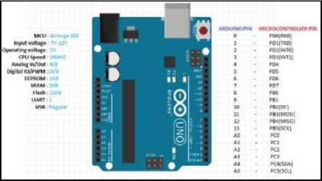

The board has 14 Digital pins, 6 Analog pins, and programmable with the Arduino IDE(Integrated Development Environment) via a type B USB cable.It can be powered by a USB cable or by an external 9 volt battery, though it accepts voltages between 7 and 20 volts. It is also similar to the Arduino Nano and Leonardo0.

1. **Bluetooth Module(HC-05):-**

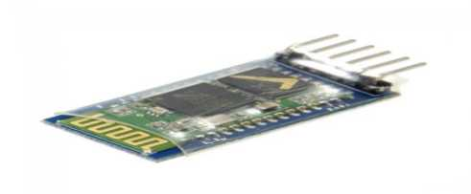

HC-05 module is an easy to use Bluetooth SPP (Serial Port Protocol) module, designed for transparent wireless serial connection setup. Serial port Bluetooth module is fully qualified Bluetooth V2.0+EDR (Enhanced Data Rate) 3Mbps Modulation with complete 2.4GHz radio transceiver and baseband . . It uses CSR Bluecore 04-External single chip Bluetooth system with CMOS technology and with AFH(Adaptive Frequency Hopping Feature). It has the footprint as small as 12.7mmx27mm. Hope it will simplify your overall design/development cycle.

* **Pins Configuration(Bluetooth):-**

|  |  |  |
| --- | --- | --- |
| **Pin Number** | **Pin Name** | **Description** |
| 1 | Enable / Key | This pin is used to toggle between Data Mode (set low) and AT command mode (set high). By default it is in Data mode |
| 2 | Vcc | Powers the module. Connect to +5V Supply voltage |
| 3 | Ground | Ground pin of module, connect to system ground. |
| 4 | TX – Transmitter | Transmits Serial Data. Everything received via Bluetooth will be given out by this pin as serial data. |
| 5 | RX – Receiver | Receive Serial Data. Every serial data given to this pin will be broadcasted via Bluetooth |
| 6 | State | The state pin is connected to on board LED, it can be used as a feedback to check if Bluetooth is working properly. |
| 7 | LED | Indicates the status of Module   * Blink once in 2 sec: Module has entered Command Mode * Repeated Blinking: Waiting for connection in Data Mode * Blink twice in 1 sec: Connection successful in Data Mode |
| 8 | Button | Used to control the Key/Enable pin to toggle between Data and command Mode |

**3)Lcd Display(16x2):-**

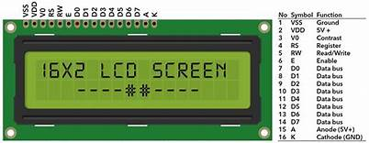

### Liquid Crystal Display(LCDs) provide a cost effective way to put a text output unit for a microcontroller. As we have seen in the previous tutorial, LEDs or 7 Segments do no have the flexibility to display informative messages. This display has 2 lines and can display 16 characters on each line. Nonetheless, when it is interfaced with the micrcontroller, we can scroll the messages with software to display information which is more than 16 characters in length.Alphanumeric displays are used in a wide range of applications, including palmtop computers, word processors, photocopiers, point of sale terminals, medical instruments, cellular phones, etc. The 16 x 2 intelligent alphanumeric dot matrix display is capable of displaying 224 different characters and symbols. A full list of the characters and symbols is printed on pages 7/8

### **Pin Identification and Configuration(Lcd 16x2):**

|  |  |  |
| --- | --- | --- |
| **Pin No** | **Function** | **Name** |
| 1 | Ground (0V) | Ground |
| 2 | Supply voltage; 5V (4.7V – 5.3V) | Vcc |
| 3 | Contrast adjustment; through a variable resistor | VEE |
| 4 | Selects command register when low; and data register when high | Register Select |
| 5 | Low to write to the register; High to read from the register | Read/write |
| 6 | Sends data to data pins when a high to low pulse is given | Enable |
| 7 | 8-bit data pins | DB0 |
| 8 | DB1 |
| 9 | DB2 |
| 10 | DB3 |
| 11 | DB4 |
| 12 | DB5 |
| 13 | DB6 |
| 14 | DB7 |
| 15 | Backlight VCC (5V) | Led+ |
| 16 | Backlight Ground (0V) | Led- |

### **LCD (16X2)Specifications:**

* Operating Voltage is 4.7V to 5.3V
* Current consumption is 1mA without backlight
* Alphanumeric LCD display module, meaning can display alphabets and numbers
* Consists of two rows and each row can print 16 characters.
* Each character is build by a 5×8 pixel box
* Can work on both 8-bit and 4-bit mode
* It can also display any custom generated characters
* Available in Green and Blue Backlight

**3)Potentiometer:-**

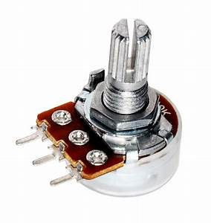

**3)Breadboard:-**

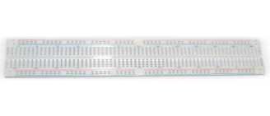

**4)Connecting Wire:-**

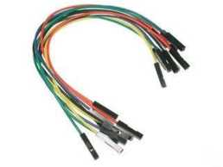

* Software Used:
* Arduino Uno Software Programe:

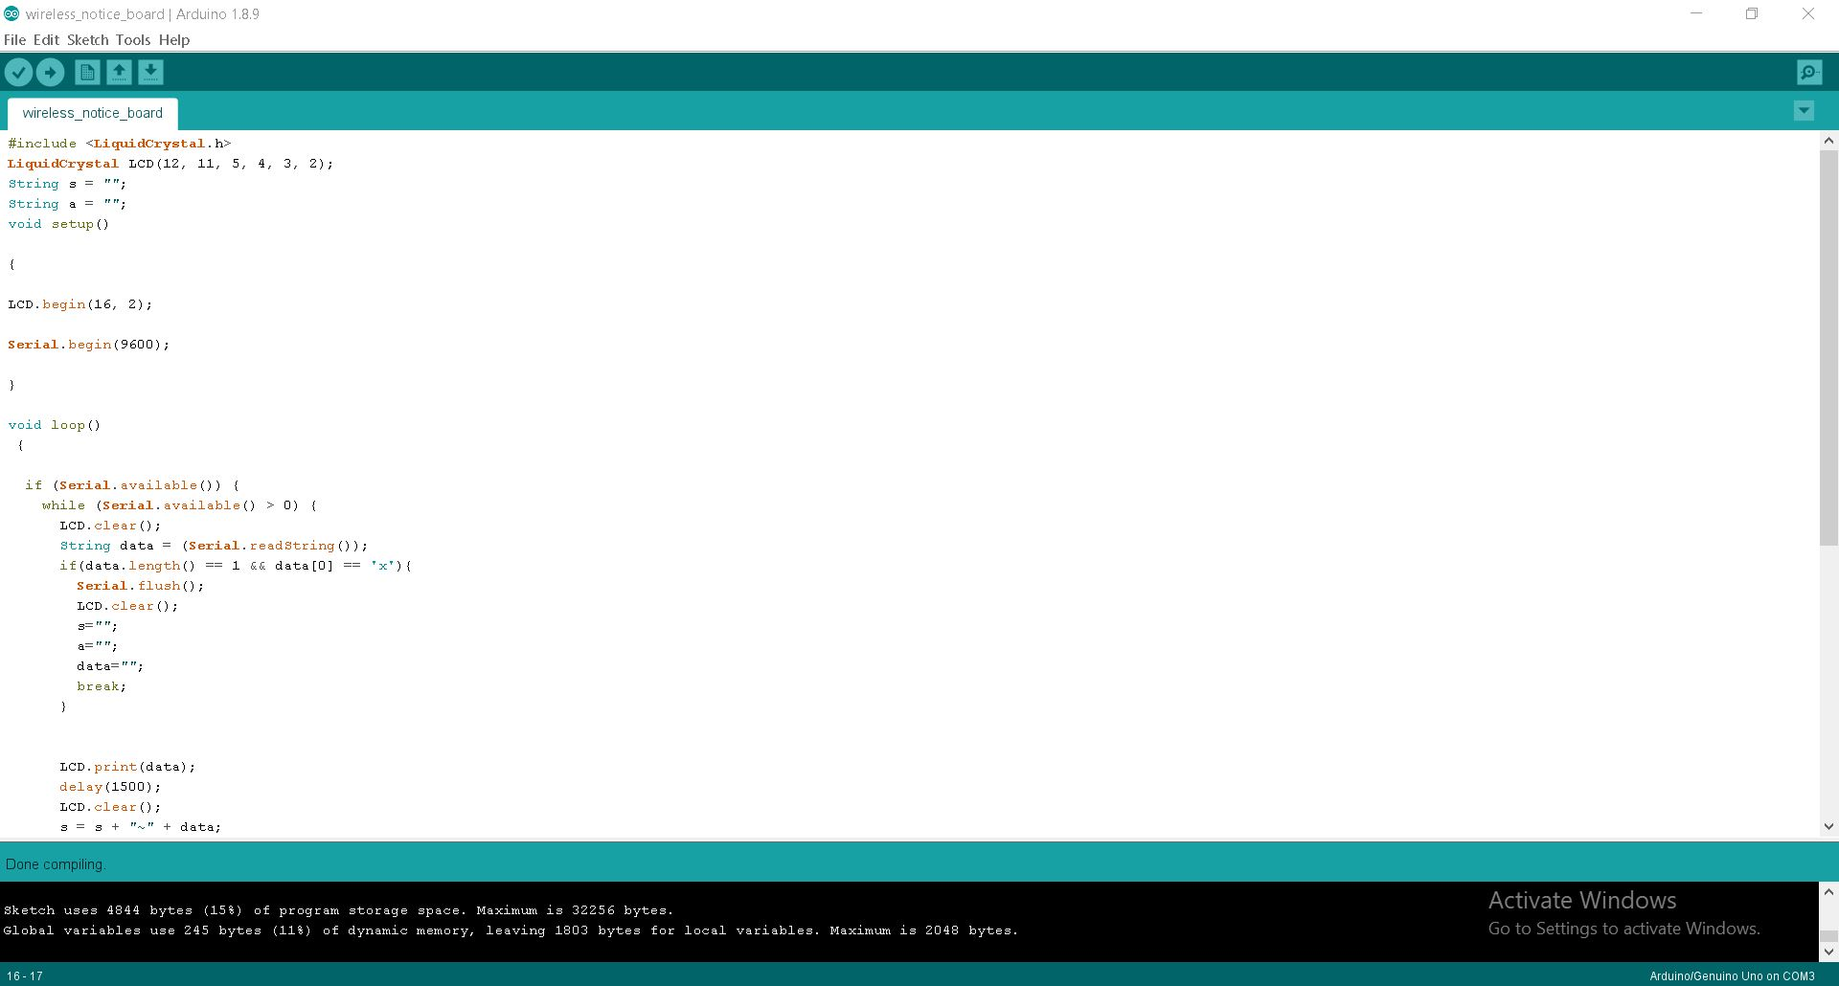

**RESULTS:-**

***The following results are obtained when we successfully completed the project:***

1)Uploading Program To Arduino Uno Board:

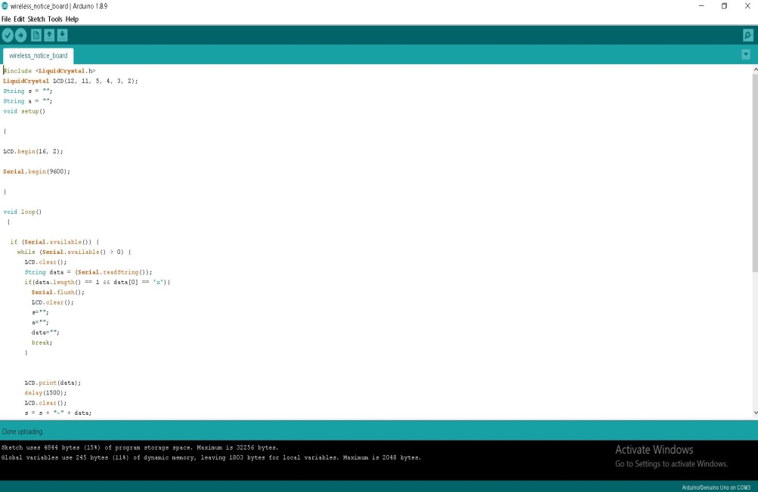

2)Actual Output Of The Project:

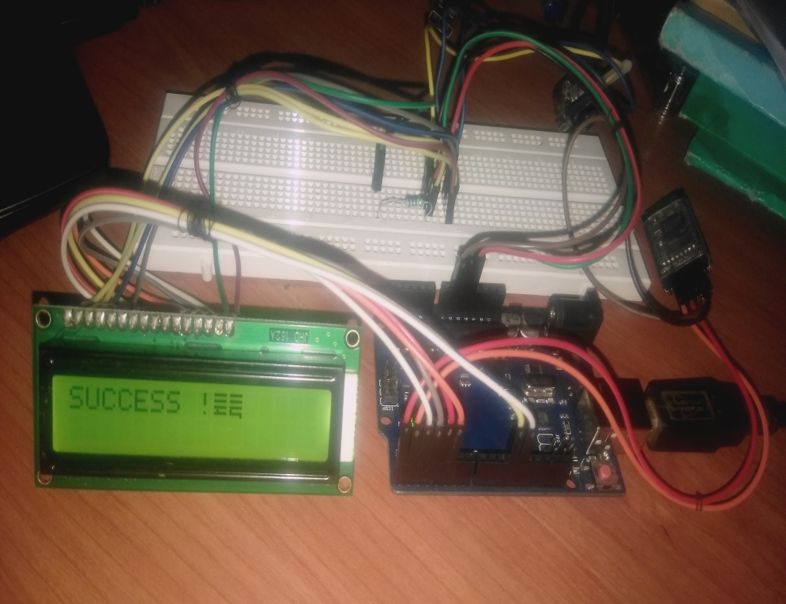

**ADVANTAGES:-**

* High accuracy
* Low cost
* Reliable
* Real time weather monitoring
* More flexible
* Weather parameters can be analyzed online with grahical presentation.

**DISADVANTAGES:-**

* The Bluetooth module has low range so we cannot operate it for medium distances.
* need big and good quality of display depending on apllication

**APPLICATIONS:-**

* This proposed system has many upcoming applications in educational institutions and organizations, crime prevention, traffic management, railways, advertisements etc. Been user friendly, long range and faster means of conveying information are major bolsters for this application.
* By using this proposed methodology we can enhance the security system and also make awareness of the emergency situations and avoid many danger

**FUTURE SCOPE:-**

In this world Mobile Phones and the related technologies are becoming more and more prevalent. Various technical arenas in the field of Telecommunication and Embedded Systems are becoming omnipresent in the people. The use of cell phones has rapidly increased over the last decade and a half Upgradation in networking technologies has encouraged the development and growth of very dense networks. Now-a-days the general mass prefer communicating while on the move therefore landlines usage has been drastically reduced. Notice boards are one of the widely used ones ranging from primary schools to major organizations to convey messages at large. A lot of paper is been used and which is later wasted by the organizations. This in turn leads to a lot of deforestation thus leading to global warming. Small innovative steps in making use of technology for regular purposes would have an adverse effect on the environment issues which we are presently concerned about.

**CONCLUSION:-**

Hence, we able to see desired message in lcd display using arduino by pairing the smartphone with Bluetooth module.the output was verified by displaying various messages regarding important notices and other messages.

This proposed system in this paper has many upcoming applications in educational institutions and organizations, crime prevention, traffic management, railways, advertisements etc. Been user friendly, long range and faster means of conveying information are major bolsters for this application. By using this proposed methodology we can enhance the security system and also make awareness of the emergency situations and avoid many dangers.

**REFERENCES:-**

* [www.circuitdigest.com](http://www.circuitdigest.com)
* <https://www.instructables.com/id/Wireless-Notice-Board-Bluetooth/>
* <https://www.google.com/url?sa=t&rct=j&q=&esrc=s&source=web&cd=1&cad=rja&uact=8&ved=2ahUKEwjMloSY-eLhAhXN7nMBHfu2CNoQFjAAegQIAxAC&url=https%3A%2F%2Fwww.ijert.org%2Fresearch%2Fwireless-e-notice-board-using-bluetooth-technology-IJERTCONV6IS07092.pdf&usg=AOvVaw3BKINxEymsL43ZxsfcnX9D>
* **Electronic Components: A Complete Reference for Project Builders** 1st Edition by DELTON T. HORN